Game Analysis Worksheet
Name of the game: Riichi Mahjong (Japanese variant of mahjong)
Publisher: Traditional game; rules standardized by Japan Professional Mahjong League (JPML) and World Riichi Championship (WRC). Popularized by digital platforms like Mahjong Soul (Yostar, 2018).
Date of Publication: Originated in 1920s Japan
Operational Rules
Number of Players and Type of Interaction
4 players; competitive, simultaneous turns with indirect interaction (discards affect others).
Race vs Brawl
Pure Race Pure Brawl
X
1 10
List of actions players can take in the game (Verbs of the game)
Draw (tsumo), discard, pon (take discard for triplets), chi (take for sequence), kan (take for quad), riichi (declare ready), ron (win on discard), tsumo (self-draw win), wash (shuffle tiles), build wall, pass.

Goal of the Game
Finite vs Infinite Game (Victory Conditions)
Be first to complete winning hand: 4 melds (sets/sequences) + 1 pair + at least 1 yaku (scoring pattern). Score points from opponents, reach point limit to win overal.
Finite Game: Each round ends with mahjong (ron/tsumo); game ends when one player reaches point limit (e.g., 30k–45k) or after fixed rounds/hours

Feedback Systems
Physical elements | Visual elements
Tactile  X  1 5 | Aesthetic Appeal  X  1 5
Kinesthetic  X  1 5 | Legibility  X  1 5
Audio Elements | Conceit Matrix
Music/ sfx  X  1 5 | 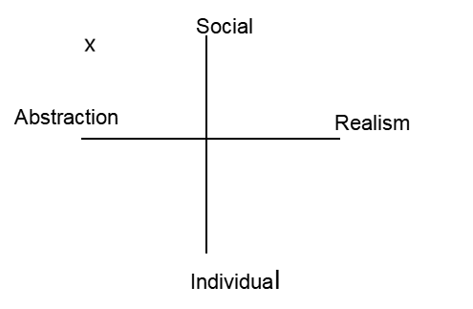
Player sound

X
1 5

Magic Bullet Analysis
Must Learn
Psychomotor | Cognitive | Affective
Sort 13 tiles in hand (2–3 sec, pattern: honors left) | Remember 3 sults (manzu/pinzu/souzu 1-9) + basic yaku (Riichi/Tanyao) | The thrill of the first "Pon!" (announce loudly)
Can Learn
Psychomotor | Cognitive | Affective
Lightning pon/chi, grab | Suji analysis | Tilt control
External Learning
Psychomotor | Cognitive | Affective
Wash speed drills | Yaku-charts + Majsoul app (shanten calc) | Clubs, tournaments, mindset training
Coincidental Learning
Psychomotor | Cognitive | Affective
Automatic motor skills from parties | Intuitive table feel, memory discards | Getting used to losing, bonding
Bullet Sketch

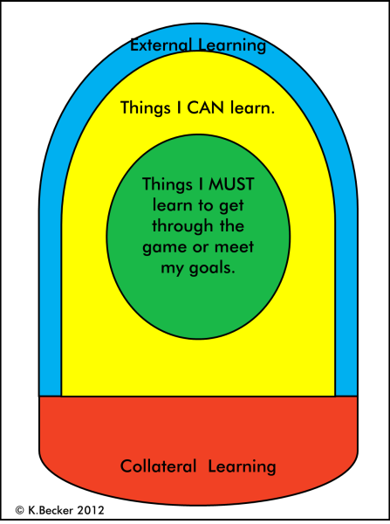

Other Notes:
Riichi Mahjong (a Japanese variant of mahjong) is a 136-tile mind game where the goal is to be the first to form a winning hand of four melds and a pair, while holding at least one yaku. Its strict structure (richi-bet, furiten, suji, genbutsu) makes it one of the most effective tools for training working memory and executive functions. The player must remember up to 70 discarded tiles per round, calculate shanten (how many steps to tenpai), analyze safe discards, predict opponents' actions, and instantly react to pon/chi/kan. This requires constant updating and manipulation of information in working memory—a key component of executive function. Research confirms that regular mahjong practice (including Riichi) significantly improves cognitive performance. Chen et al. (2022) conducted a longitudinal study in children in Frontiers in Psychology and found a 10–15% increase in the Processing Speed Index (PSI) after 12 weeks of training. The authors used the Wechsler Intelligence Scale and statistical analysis, demonstrating that mahjong outperforms many traditional cognitive training methods in terms of information processing speed. In older adults, the effect is even more pronounced: a 2024 scoping review (Journal of Prevention of Alzheimer's Disease) analyzed 28 studies and concluded that mahjong slows cognitive decline, improves working memory and attention, and reduces the risk of dementia. The social aspect (loud announcements of "Riichi!", "Mahjong!", and emotional reactions to ron) adds an affective layer: emotional regulation and stress resilience are trained. According to Bloom's revised taxonomy (Anderson & Krathwohl, 2001), Riichi encompasses all levels: memorization (yaku and tiles), understanding (tenpai mechanics), application (quick reset), analysis (table reading), evaluation (richi risk), and creation (personal defensive strategy). Digital platforms (Mahjong Soul, Tenhou) enhance the effect through replays and statistics. Riichi Mahjong receives a 4.8/5 as an educational tool: its near-perfect balance of cognitive load, psychomotor skills, and social interaction makes it valuable for therapy, schools, and family play.

